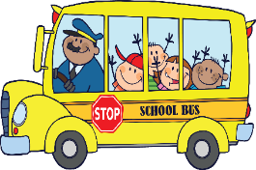

To ensure that each student will receive a bag lunch, please turn in this form to the School Cafeteria **2 WEEKS** prior to the field trip. Coordinate pick up of meals with Cafeteria.

Date of Fieldtrip: __________________ Time needed: _________________

Teacher: _____________________________ Room: ______________________

|  |  |  |  |  |
| --- | --- | --- | --- | --- |
| **Student’s Name** | **Student ID Number** | **Breakfast** | **Lunch** | **Peanut Allergy?** |
| 1) |  |  |  |  |
| 2) |  |  |  |  |
| 3) |  |  |  |  |
| 4) |  |  |  |  |
| 5) |  |  |  |  |
| 6) |  |  |  |  |
| 7) |  |  |  |  |
| 8) |  |  |  |  |
| 9) |  |  |  |  |
| 10) |  |  |  |  |
| 11) |  |  |  |  |
| 12) |  |  |  |  |
| 13) |  |  |  |  |
| 14) |  |  |  |  |
| 15) |  |  |  |  |
| 16) |  |  |  |  |
| 17) |  |  |  |  |
| 18) |  |  |  |  |
| 19) |  |  |  |  |
| 20) |  |  |  |  |